**Hybrid Cloud Networking**

* Consider a scenario where you have workloads on-premise and also on cloud and for the application needs there should be communication between workloads on cloud and on-premise 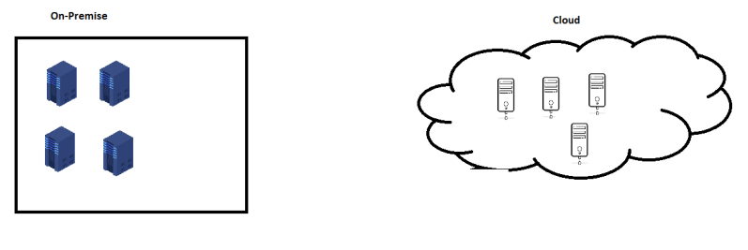
* Solution 1: Consider having workloads on public internet (i.e. each server will have public ip address and can be accessed over internet)
  + Solves the problem of communication
  + Cons:
    - Your servers are exposed to internet and any one from internet can access your servers.

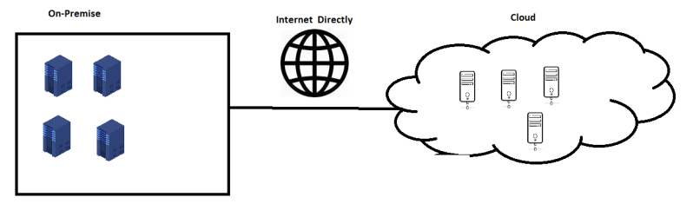

* Solution 2: Use Virtual Private Networks (VPN) to be specific site to site VPN
  + Rather than exposing all servers to the public internet, here we would set up a vpn device on-premise and vpn device on-cloud. Both of these devices will be on public internet with strict rules of communication
  + With this your servers will not require public ip address and still communicate to the servers on the other network using private ip address

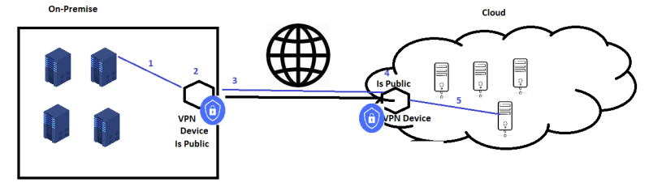

* Solution 3: Consider leased line or direct line to cloud

**Compute Needs for the Enterprise on the Cloud**

* To make applications run of cloud we would require vm’s with various factors.
* Size of the VMs:
  + number of vCPUS:
  + RAM size:
  + Storage Size:
* Operating System: Generally we search or create Server Operating Systems
  + Most Clouds support
    - Linux
    - Windows
    - Free BSD
* Licensing:
  + BYOL (Bring your own license)
  + Pay as you go
* Cost: Ensure you choose a Compute which saves cost.

**Exercise:**

* Scenario: Your organization is running application on premise on 50 Servers
  + 10 servers are running redhat linux with mysql installed on it
  + 20 servers are running application server tomcat with Ubuntu OS
  + 2 servers are running cache servers with with ubuntu os and redis cache installed
  + 3 servers are used for load balancing
  + we have 15 servers on the other site where we use it for backup and archival
* Exercise 1: Can you draw the basic diagram representing all these servers
* Exercise 2: Can you try to speak about a plan to do the same thing on cloud.